HOSPITAL MANAGEMENT SYSTEM

# A MINI-PROJECT REPORT

***Submitted by***

**CHARULATA.M.G 220701053**

**DARSHITA.M 220702055**

***in partial fulfillment of the award of the degree***

***of***

# BACHELOR OF ENGINEERING

**IN**

**COMPUTER SCIENCE AND ENGINEERING**



# RAJALAKSHMI ENGINEERING COLLEGE AUTONOMOUS, CHENNAI

**NOV/DEC, 2023**

## BONAFIDE CERTIFICATE

Certified that this mini project **“HOSPITAL MANAGEMENT SYSTEM**” is the bonafide work of **“CHARULATA.M.G** and **DARSHITA.M”** who carried out the project work under my supervision.

**SIGNATURE**

**Dr.N.DURAIMURUGAN**

Associate Professor,

Computer Science & Engineering Rajalakshmi Engineering College Thandalam, Chennai -602105.

Submitted for the End semester practical examination to be held on

**INTERNAL EXAMINER EXTERNAL EXAMINER**

## ACKNOWLEDGEMENT

I express my sincere thanks to my beloved and honorable chairman **MR.S.MEGANATHAN** and the chairperson **DR.M.THANGAM MEGANATHAN** for their timely support and encouragement.

I am greatly indebted to my respected and honorable principal **Dr. S.N.MURUGESAN**

for his able support and guidance.

No words of gratitude will suffice for the unquestioning support extended to us by my head of the department **Dr. P. KUMAR,** and my Academic Head **Dr.R.SABHITHA,** for being ever supporting force during my project work.

I also extend my sincere and hearty thanks to my internal guide **Dr.N.DURAIMURUGAN** for his valuable guidance and motivation during the completion of this project.

My sincere thanks to my family members, friends and other staff members of Computer Science and Engineering.

**CHARULATA.M.G(220701053) DARSHITA.M(220701055)**

# ABSTRACT

The Hospital Management System (HMS) is a robust web-based application built using PHP, CSS and MYSQL, designed to streamline patient-doctor interactions and optimize appointment scheduling. This system allows hospitals to manage doctor and patient records, appointments and basic contact services within a secure and user-friendly platform.

The system enables doctors to register and manage their profiles efficiently. Once registered, doctors can view a list of patients, access patient details, and check scheduled appointments. This functionality helps doctors prepare for consultations and maintain patient records for improved healthcare services. By providing doctors with a centralized system for appointment management, the HMS ensures streamlined workflows and better care for our patients.

Patients, on the other hand, can register and access personalized profiles to book appointments with their chosen doctors. The platform offers flexibility for patients to reschedule or cancel appointments as needed. The appointment view feature allows patients to track upcoming and past appointments, making it easier to manage their healthcare interactions. The system also includes a “Contact Us” page to address user inquiries or support requests, ensuring accessibility and addressing potential issues.

HMS offers a visually appealing, accessible, and mobile-friendly experience, adaptable across devices and screen sizes. This Hospital Management System aims to minimize administrative burdens, improve patient-doctor communication, and ensure efficient appointment scheduling for better healthcare delivery.

# TABLE OF CONTENTS

|  |  |  |
| --- | --- | --- |
| **CHAPTER NO.** | **TITLE** | **PAGE NO** |
|  | **ABSTRACT** | **4** |
| **1** | **INTRODUCTION** | **6** |
|  | 1.1 INTRODUCTION | 6 |
|  | 1.2 SCOPE OF THE WORK | 6 |
|  | 1.3 PROBLEM STATEMENT | 6 |
|  | 1.4 AIM AND OBJECTIVES OF THE PROJECT | 7 |
| **2** | **SYSTEM SPECIFICATIONS** | **8** |
|  | 2.1 HARDWARE SPECIFICATIONS | 8 |
|  | 2.2 SOFTWARE SPECIFICATIONS | 8 |
| **3** | **ARCHITECTURE DIAGRAM** | **9** |
| **4** | **MODULE DESCRIPTION** | **10** |
| **5** | **SYSTEM DESIGN** | **11** |
|  | 5.1 USECASE DIAGRAM | 11 |
|  | 5.2 E-R MODEL | 12 |
|  | 5.3 DATAFLOW DIAGRAM | 13 |
|  | 5.4 ACTIVITY DIAGRAM | 15 |
| **6** | **CODING** | **18** |
| **7** | **SCREENSHOTS** | **20** |
| **8** | **CONCLUSION** | **26** |
|  | **REFERENCES** | 27 |

**CHAPTER 1**

## INTRODUCTION

The Hospital Management System (HMS) is an innovative web application designed to improve healthcare administration by providing a streamlined platform for managing patient and doctor interactions. Built with PHP, CSS, and MySQL this system enhances traditional healthcare processes by offering a solution for doctors and patients to manage appointments, maintain records, and communicate effectively. For doctors, HMS offers a simple yet powerful interface to register, view patient details, and keep track of upcoming appointments and patients benefit from a personalized experience where they can register, book appointments, reschedule, or cancel as needed. This flexibility empowers patients to manage their healthcare journey with ease and reliability.

## SCOPE OF THE WORK

The Hospital Management System (HMS) is designed as a comprehensive platform to streamline hospital operations, primarily focusing on patient and doctor management, appointment scheduling, and efficient communication. The scope of this system includes several key functionalities that cater to both doctors and patients. Doctors can register within the system, creating profiles that display their specialization, contact details, and availability, while also accessing patient records and managing appointment schedules. Patients, on the other hand, can register to create personal profiles, which they use to book, reschedule, or cancel appointments with ease. The HMS provides a view of all upcoming and past appointments for patients, allowing them to keep track of their healthcare interactions seamlessly.

## PROBLEM STATEMENT

In traditional hospital settings, managing patient-doctor interactions, scheduling appointments, and maintaining medical records often involves extensive paperwork and time-consuming manual processes. These inefficiencies can lead to scheduling conflicts, delayed or missed appointments, data inaccuracies, and difficulty in accessing patient records, all of which compromise the quality of healthcare delivery. Furthermore, the lack of a centralized system for both patients and doctors to view and manage appointments can result in communication gaps and inconsistent patient care. This Hospital Management System (HMS) project seeks to address these issues by developing a streamlined, web-based solution that enhances administrative efficiency and patient satisfaction.

By integrating a secure MySQL database to store patient and doctor information, and utilizing responsive design techniques for accessibility on any device, the HMS aims to reduce operational burdens, prevent scheduling errors, and improve the overall quality of patient care. This system addresses the need for a reliable, scalable, and efficient digital solution for healthcare provider.

## AIM AND OBJECTIVES OF THE PROJECT

The aim of the Hospital Management System (HMS) is to create an integrated, web-based solution that centralizes hospital operations to enhance patient care and streamline administrative processes. By focusing on patient and doctor interactions, appointment scheduling, and information management, HMS aims to improve healthcare accessibility, accuracy, and efficiency. The system’s objectives include developing a secure, user-friendly registration and login process for both patients and doctors, where profiles can be easily created, updated, and managed to ensure accurate data representation. For appointment management, the HMS provides flexible booking, rescheduling, and cancellation options for patients, enabling them to coordinate with doctor availability and avoid scheduling conflicts. Additionally, doctors can access an intuitive dashboard to view and manage appointments, monitor patient records, and prepare in advance, facilitating effective care delivery.

The HMS is designed to provide a centralized and easily navigable appointment tracking system, allowing both doctors and patients to review appointment history and upcoming visits, thereby enhancing communication and ensuring smoother interactions. A key feature of the system is its secure MySQL database, which safeguards sensitive data, supports efficient storage and retrieval, and is backed by regular backups for data reliability and continuity. The HMS incorporates a responsive, cross-platform interface built using CSS and Bootstrap, ensuring compatibility with various devices, including desktops, tablets, and mobile phones, making it accessible for users in different settings. Moreover, the system includes a robust contact support function, allowing users to submit inquiries, raise issues, and access assistance when needed, promoting seamless communication with the hospital administration.

Other key objectives include ensuring the scalability of the system to accommodate growing patient and doctor databases, providing role-based access control to restrict sensitive information, and implementing user activity logs for tracking actions within the system, which enhances accountability and security. Ultimately, the HMS aims to reduce administrative workload, minimize errors associated with manual scheduling, and foster a collaborative environment for better patient outcomes, positioning itself as a comprehensive solution for modern hospital management needs.

# CHAPTER 2

## SYSTEM SPECIFICATIONS

**2.1 HARDWARE SPECIFICATIONS**

Processor **:** Pentium IV Or Higher

Memory Size **:** 8GB RAM (Minimum)

HDD **:** 256 GB (Minimum)

## SOFTWARE SPECIFICATIONS

Operating System **:** WINDOWS 7 OR HIGHER

Front – End **:** HTML, CSS, JAVASCRIPT

Back – End **:** PHP, MYSQL

# CHAPTER 3

**ARCHITECTURE DIAGRAM**

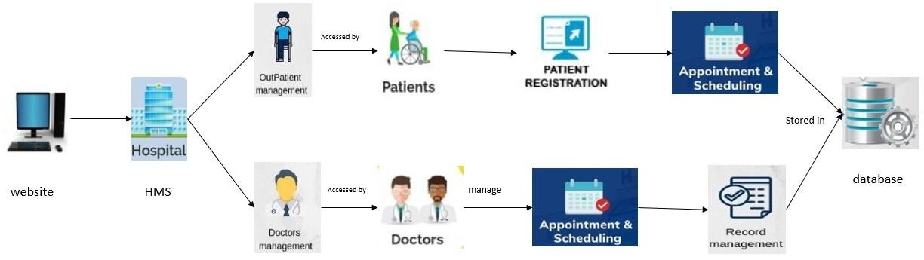

The architecture of the Hospital Management System (HMS) is designed using a **Client-Server Model** to ensure seamless integration, security, and scalability. It comprises three primary layers: the **Presentation Layer**, **Application Layer**, and **Database Layer**. The **Presentation Layer**, built using HTML, CSS, and JavaScript, provides an intuitive user interface for patients, doctors, and administrators to interact with the system via web browsers or mobile devices. The **Application Layer**, developed with PHP, acts as a middleware, processing user requests, enforcing business rules, and managing core functionalities like authentication, appointment scheduling, and billing. The **Database Layer**, powered by MySQL, stores and manages critical data such as patient records, doctor profiles, and financial information, ensuring secure and efficient data retrieval and backup. Communication between these layers occurs securely through HTTP/HTTPS protocols, while additional components like notifications and analytics interact with the core system to enhance functionality. This architecture ensures modularity, efficiency, and adaptability, meeting the diverse needs of modern healthcare facilities.

# CHAPTER 4

## MODULE DESCRIPTION

* 1. **Appointment Scheduling Module:**

The **Appointment Scheduling Module** centralizes appointment management, enabling patients to view doctor availability, book, reschedule, or cancel appointments. Both patients and doctors receive real-time updates on appointments, and automated reminders are sent to minimize missed appointments. This module simplifies the booking process and improves time management for both patients and doctors.

* 1. **Patient Management Module**

The **Patient Management Module** organizes patient data, storing details like personal information, contact data, medical history, and appointment records. This module allows doctors to access comprehensive patient profiles, giving them insight into a patient’s past medical background, ongoing treatments, and history of appointments, facilitating more informed consultations.

* 1. **Doctor Management Module:**

The Doctor Management Module helps doctors maintain their profiles, including their specialization, qualifications, and availability. Doctors can also view their schedule of appointments and access patient records directly through this module, ensuring they have the necessary information for each consultation and can manage their time effectively.

* 1. **Contact Us Module:**

The **Contact Us Module** enables users to reach out with inquiries, complaints, or support requests through a centralized form. Administrators can manage these inquiries, responding to users directly within the system, which improves communication and ensures user concerns are addressed promptly

* 1. **Review Module:**

The **Reports and Analytics Module** generates valuable insights on hospital operations, including data on patient demographics, doctor activity, appointment statistics, and revenue. These reports assist the hospital in making data-driven decisions, optimizing resources, and identifying patterns in patient care and service usage.

# CHAPTER 5

**SYSTEM DESIGN**

**5.1 USE CASE DIAGRAM**

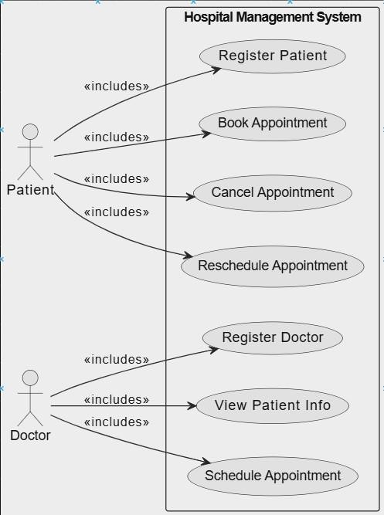

**5.2 ER DIAGRAM**

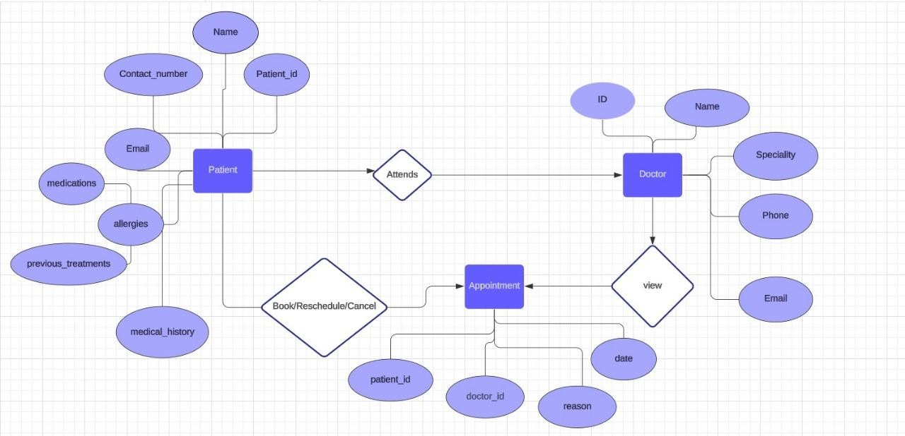

**5.3 DFD DIAGRAM**

DFD Level-0 Diagram

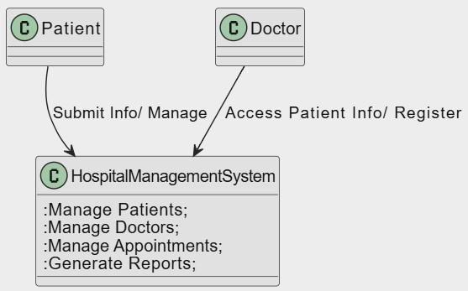

DFD Level-1 Diagram

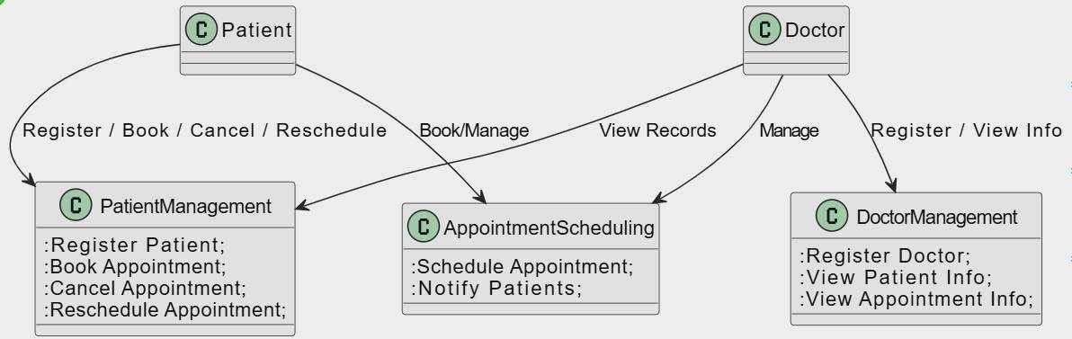

**5.4 ACTIVITY DIAGRAM**

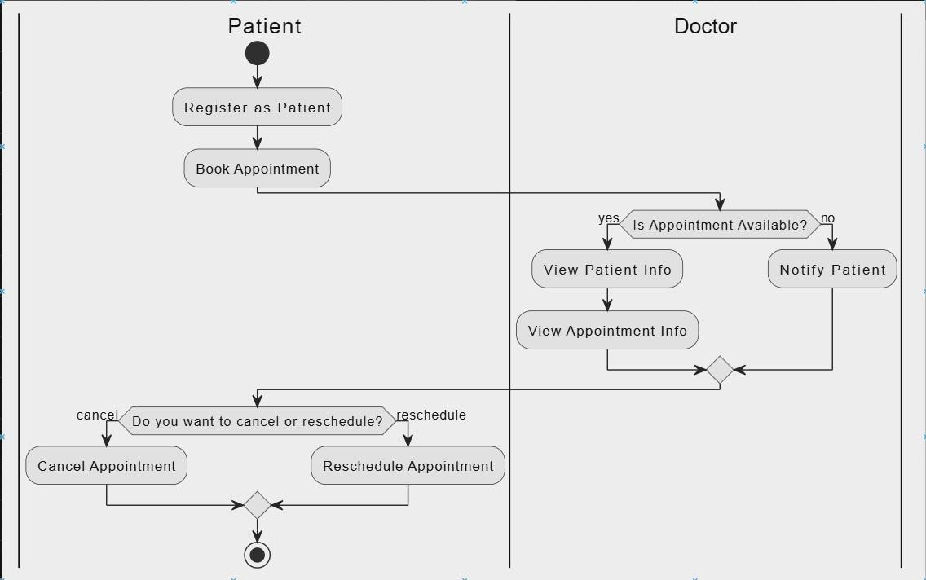

# CHAPTER 7

## SCREEN SHOTS

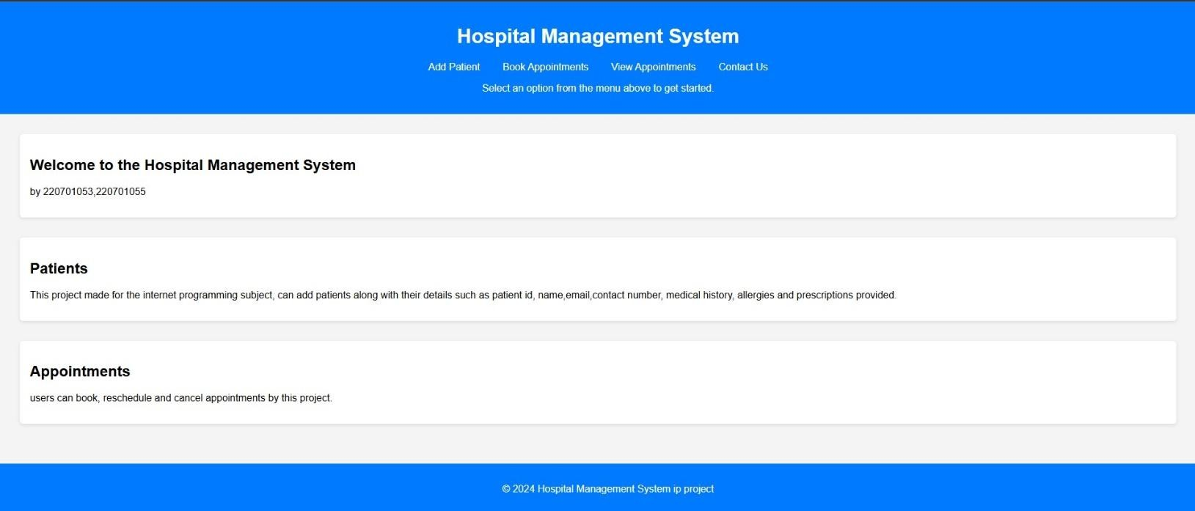

**Fig. 7.1.Patient’s Home Page**

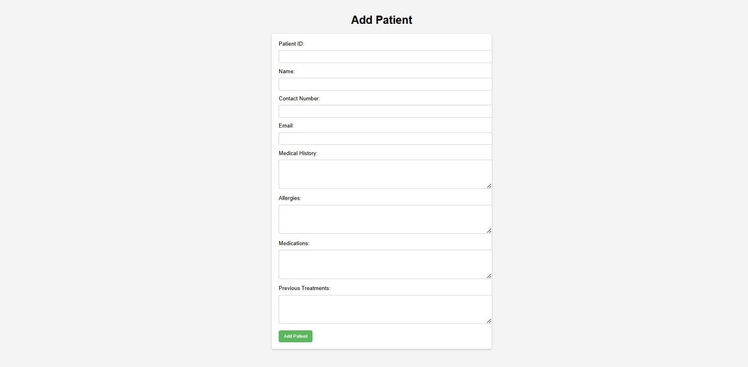

**Fig. 7.2. To Add Patients**

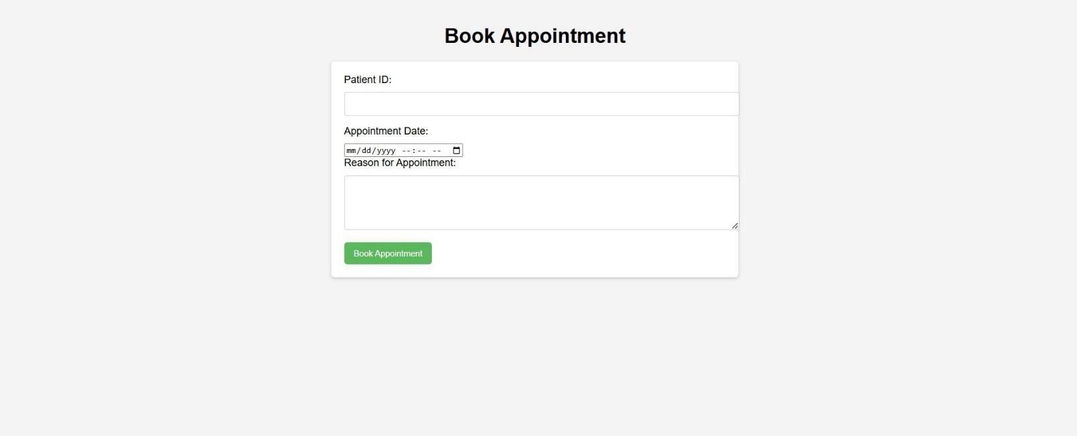

**Fig. 7.3. Appointment Booking**

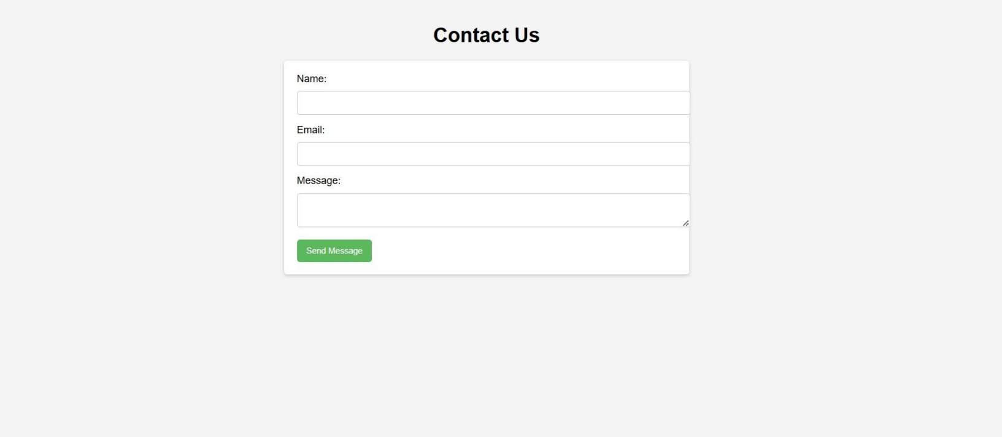

**Fig. 7.4. Contact Us**

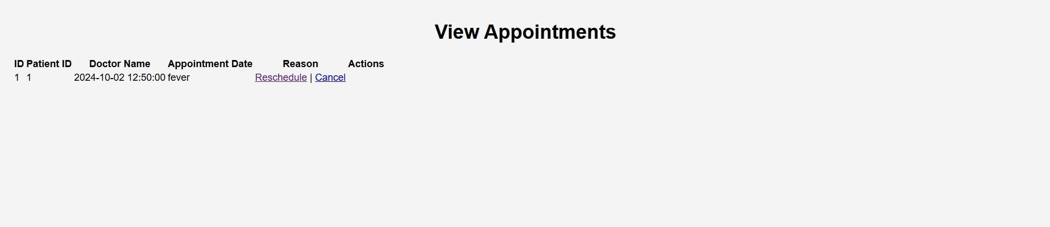

**Fig. 7.5. To View Appointments**



**Fig. 7.6. To Reschedule Appointments**

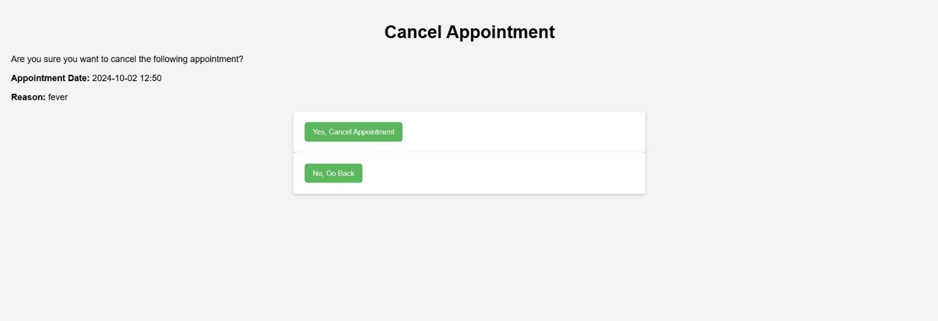

**Fig.7.7.To Cancel Appointments**

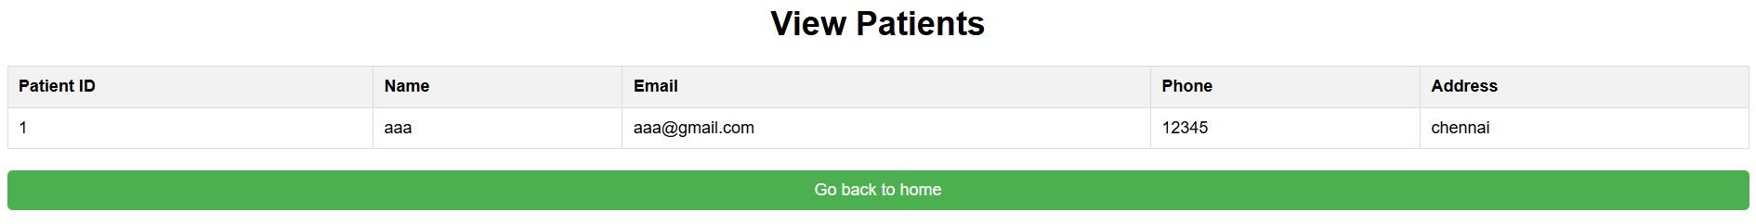

**Fig.7.8 To View Patients**

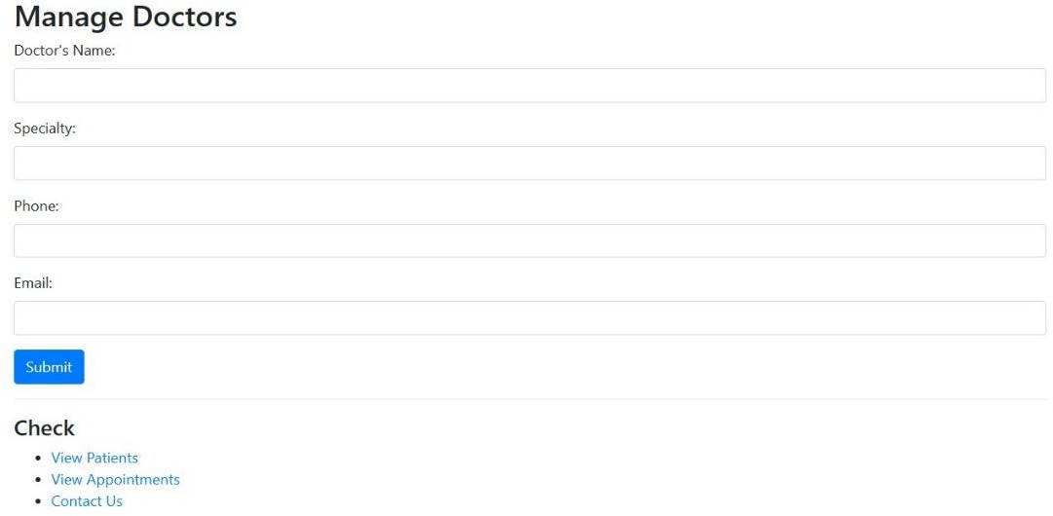

**Fig.7.9.To Manage Doctors**

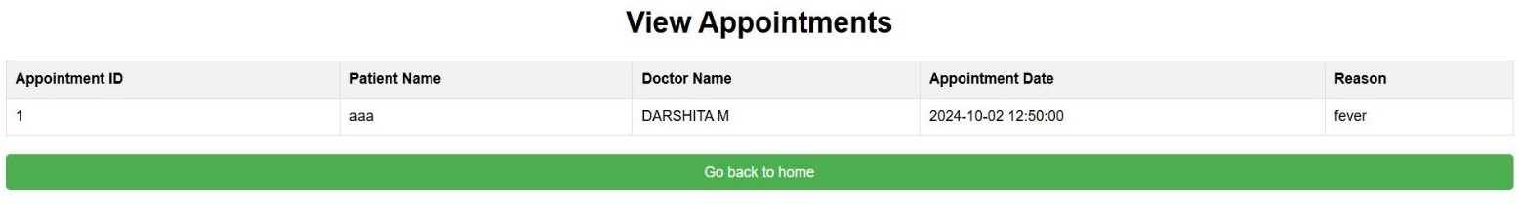

**Fig.7.10 . To View Appointments**

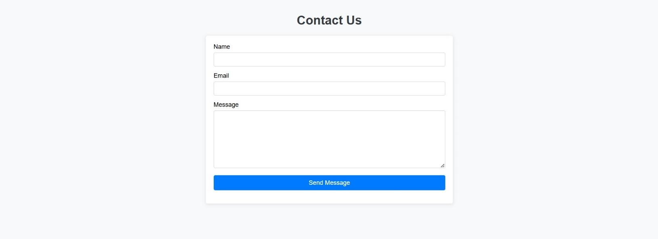

**Fig.7.11 contact page**

# CHAPTER 8

## CONCLUSION

In conclusion, the Hospital Management System (HMS) is a comprehensive solution designed to streamline the various operations within a healthcare facility, enhancing efficiency, security, and user experience for patients, doctors, and administrators. By implementing robust modules such as Patient Management, Doctor Management, Appointment Scheduling, and, the system addresses core needs for patient care coordination and doctors efficiency. Additional features, including the Contact Us and Security strengthen the system's capabilities by ensuring data- driven decision-making, effective communication, and secure data management.

The HMS not only improves the overall operational workflow but also enhances patient satisfaction by offering easy access to appointments and medical records. Doctors benefit from organized access to patient information, which aids in delivering quality care. Overall, the HMS bridges the gaps in hospital management processes, promoting a more organized, transparent, and efficient healthcare environment. This project is a significant step towards modernizing healthcare management, allowing hospitals to provide high-quality care with enhanced operational support.

# REFERENCES

HTML , CSS , JS – [www.w3schools.com](http://www.w3schools.com/)

PHP, MYSQL – [www.youtube.com](http://www.youtube.com/)